Exercise 1: GC-MS
GC-MS trace is a mixture of compounds of the form C_{x}H_{y}O₂, (x = 7 – 25, y = 14 – 50)
One of the following retention times will be assigned to you:
- 15.1; b) 22.7; c) 37.0; d) 43.2; e) 49.0

- Will the molecular ion be an even or odd mass?

- Identify the molecular ion for the peak assigned to you (m/z 180 – 350)
  - Click on the chromatographic peak (or click and drag across)
  - Remember the molecular ion can be quite weak in intensity

- Why is the [M+2] isotope insignificant?

- From the mass, identify the molecular formula (all are C_{x}H_{2x}O₂, x = 10 – 24)

- Search the NIST database for your molecular formula and match the experimental spectrum to a unique compound
  - Pin the spectrum tab
  - Right click and select Library Search

Exercise 2: LC-ESI-MS/MS
One of the following nominal masses will be assigned to you:
- m/z 152; b) m/z 195; c) m/z 311; d) m/z 323; e) m/z 331; f) m/z 455

- Create an extracted ion chromatogram for this m/z. What is the retention time?
  - Pin the chromatogram tab
  - Right click on the chromatogram and select ‘Ranges…’
  - Scan filter = FTMS + p ESI Full MS [120.00-800.00]
  - Plot type = ‘Mass range’
  - Range(s) = {the mass of your molecular ion}
Note: m/z 195 has 2 chromatographic peaks. The major peak at t = 0.9 minutes is chemical noise and should be ignored.

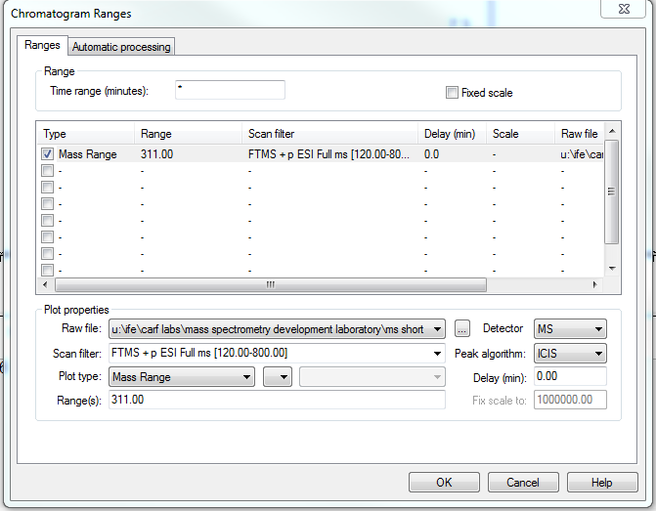

- Re-pin the spectrum tab, then click and drag across the chromatographic peak. Examine the molecular ion region of the resulting spectrum (click and drag on the spectrum to zoom in). What is the charge state?

- Is there an even or odd number of nitrogens? Are there any halogens?
- Identify the monoisotopic mass to 4 decimal places.
  - Right click on the spectrum and select ‘Display Options…’
  - Select the Labels tab
  - Change decimals to 4
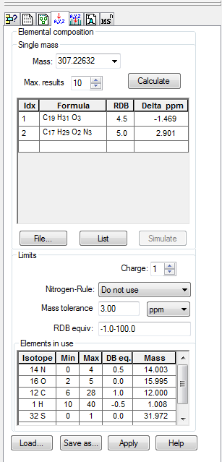
- List candidates for the molecular formula and the mass error
  - Right click on the m/z label of the monoisotopic mass on the spectrum
  - Select ‘Generate Formula from Mass’
  - Copy the search criteria from the figure. Include 1 – 2 halogens only if identified in (3).
    - To add S or halogens, click the blank row below 1H, select the element(s), add Min and Max, and click ‘Add to List’.
  - Click Calculate

- Simulate the isotope pattern of the best candidate formula
  - In your list, click the number in the Idx column corresponding to your formula
  - Click Simulate

- Examine the MS/MS spectrum for your ion and identify the nominal mass of the major fragment ion
  - Pin the chromatogram tab
  - Right click on the chromatogram and select ‘Ranges…’
  - Scan Filter = {Search for your mass in the list of precursors}
  - Plot type = TIC
  - Press OK
  - Re-pin the spectrum tab
  - Average across the chromatographic peak with the same retention time as in Part 1
Exercise 3: Peptide LC-MS
- Identify the monoisotopic mass in the high-resolution spectrum for the chromatographic peak eluting at 8.4 minutes.
  - Click and drag across the chromatographic peak
  - Zoom in on the mass spectrum by clicking and dragging
- Identify the charge state of this ion
- Create an extracted ion chromatogram for this peak
  - Pin the chromatogram tab
  - Click and drag across the ion in the spectrum
- Calculate the nominal mass of the neutral molecule that yields this peak, assuming the ion is of the type [M+zH]^{z+} (where z = charge state)
- List candidates for the molecular formula and the mass error
  - Right click on the m/z label of the monoisotopic mass on the spectrum
  - Select ‘Generate Formula from Mass’
  - Use the following search criteria:
    - Charge state (see Q2)
    - Mass tolerance = 3 ppm
    - C = 100 – 125
    - H = 150 – 200
    - N = 30 – 35
    - O = 30 – 35
    - S = 2. To add S, click the blank row below 1H, select sulfur, set Min and Max to 2, and click ‘Add to List’.
  - Click Calculate
- What ionization source was likely used to produce this spectrum?

